CSA 283: Final

Name: ______________________________________ Section: _____ _____

Please write legibly. Ask questions if something is unclear. Write down any assumptions you make.

Keep your answers concise. Write the minimum that is necessary when explaining.

Some useful formulas:
d_{trans} = L/R d_{prop} = d/s

Consider the network diagram shown in the supplemental handout. The diagram depicts the following:

- Four end systems labeled A, B, C, and D
- One switch labeled S1
(Switch interfaces are labeled 1 – 3)
- One 802.11 wireless access point labeled A1
- Four routers labeled R1, R2, R3, and R4
  - The interfaces of R2 are labeled 1 – 3
  - Router R1 is performing NAT

Information held at various nodes is given in tables on the page following the diagram.

Use the diagram and tables to answer the following questions. Write no more than one sentence when on “Why of Why not?” questions.

- Consider a message being sent from host A to host C and the segments, datagrams, and frames that will be generated to carry the message.
- The socket on A that is being used to send messages has a port number of 4500.
- The port number of the socket being used on C to receive the message is 80.

    - Would the switch labeled S1 have a MAC address? (3 points)

    - Which protocol will A use to determine the IP address of C? (3 points)

    - What protocol would A use to determine the MAC address of R1?
(3 points)
    - Following the exchange in the previous question, how would the switch table for S1 have been modified? (3 points)

    - Taking into account the results of the previous question, when A is sending a packet to C, will the network interface adapter of B receive the frame that is sent by A to R1? Why or why not? (4 points)

    - Can A transmit a frame to R1 via S1 while R1 is transmitting a frame to B via S1 without colliding? Why or why not? (3 points)

    - When a datagram travels from A to C, what will the source and destination physical addresses be in the frame that travels from R1 to R2? (4 points)

Source ____________________________________

Destination ____________________________________

    - When A is sending a datagram to C, what will be the source IP address and port number in the packet/segment as it travels between A and R1?
(4 points)

Source IP ____________________________________

Source Port ____________________________________

    - When A is sending a datagram to C, what will be the source IP address and port number in the packet/segment as it travels between R5 and C?
(4 points)

Source IP ____________________________________

Source Port ____________________________________

    - Based on the forwarding table given for R2, when A is sending a packet to C, will it forward the packet to R3 or R4? (3 points)
    - If C wants to reply back to A, will it use ARP to get the MAC address of A? Why or why not? (4 points)

    - If C sends a reply back to A, what will the destination IP address and destination port number be in the datagram/segment as it travels between R2 and R1? (4 points)

Destination IP ____________________________________

Destination Port ____________________________________

    - If C sends a reply back to A, what will the destination IP address and destination port number be in the packet/segment as it travels between R1 and A? (4 points)

Destination IP ____________________________________

Destination Port ____________________________________

    - Give the Classless InterDomain Routing (CIDR) notation for the subnets identified by forwarding table of R2. Indicate approximately how many hosts each sub-net could contain. (6 points)

CIDR notation Approx. Number of Hosts

________________________ __________

________________________ __________

________________________ __________

- Consider a message being sent from host A to host B and the segments, datagrams, and frames that will be generated to carry the message.
- The socket on A that is being used to send messages has a port number of 4000.
- The port number of the socket being used on B to receive the message is 3000.

Assume the tables have been reset to their original state as written on the sheet. Again, use no more than one sentence to answer.

- Would A need to use ARP to get the MAC address of B? Why or why not? (3 points)

- What would be the source and destination IP addresses be in the datagram that goes from A to B? (4 points)

Source IP ____________________________________

Destination IP ____________________________________

- Would R1 receive the frame sent by A? Why or why not?(4 points)

- After A has sent a datagram to B, how would the switch table for S1 be updated? (3 points)

- If B wants to reply back to A, would be it need to use ARP to get the MAC address of A? Why or why not?(4 points)

- Suppose you wrote a server and your classmate wrote a client, if you were testing them for compatibility using computers in this classroom, would the communication be more like question 1 or question 2? (2 points)

- Which is faster? Go-Back-N or Selective-Repeat? Why? Answer should be no more than two sentences. (4 points)

- Give definitions for the following terms using one or two sentences. If the term is an acronym, also state what the letters in the acronym stand for and give a definition. Use no more than two sentences to describe the term.

a. Jam Signal (6 points):

b. RFC (6 points):

c. CSMA/CA (6 points):

d. ICMP (6 points)

e. Conditional GET (6 points)

- Use the distance vector algorithm to update D’s forwarding table.

Routers are identified by upper case letters i.e. A, B, C, D, F

Subnets (destinations) are identified by lower case letters i.e. q, r, u, v, x, z.

The neighbors of a router are one hop (one subnet) away.

The following is the routing table at router D:

Destination Subnet | Next Router | Number of Hops to Dest.
r | A | 10
w | C | 7
x | - | 1
y | B | 4
z | B | 5
… | … | …

Assume that router D receives the following advertisement from neighbor A:

Destination Subnet | Next Router | Number of Hops to Dest.
u | F | 6
w | - | 1
x | - | 1
y | Q | 2
z | C | 5

As a result of the above advertisement, D may (or not) change its routing table. Show D’s updated routing table below: (18 points)

Please list the destinations in alphabetical order.

Destination Subnet | Next Router | Number of Hops to Dest.

- Use the constants below to answer the following questions. Show work for partial credit. Indicate the units for each answer. Show times to five decimal places. Assume processing and queuing delays are negligible.

Bits being transmitted 40,000 bits
Packet Size 500 bits
Link Bandwidth 20,000 bps
Link Lengths 20,000 Meters
Propagation Speed 2.8 x 10⁸ Mps

a. Calculate the propagation delay for a single link. (2 points)

b. Calculate the transmission delay for a single packet and a single router.
(2 points)

- Calculate the bit time (time to send a single bit) for this bandwidth.
(3 points)

- Assuming there are six links connected by routers and that processing and queuing delays are negligible, calculate the time required for a single packet to travel from A to B at the end of the sixth link. (6 points)
A
B

- Again, assume there are six links connected by routers and that processing and queuing delays are negligible. For pipelined transmission, calculate the time needed for the entire file to reach B at the end of the sixth link. (8 points)

- Consider the following scenario:

A network application running on frodo.nps.edu wants to transmit packets for sam.muohio.edu. In the following, assume that all DNS servers (including the local name server) use caching and that all DNS caches initially contain bare minimal information. With the exception of the recursive query to the local name server, assume all queries are handled iteratively. DNS server names are as follows:

TLD DNS server, edu: dns.tld.edu
TLD DNS server, org: dns.tld.org
Local DNS server, nps: local.nps.edu
Local DNS server, muohio: local.muohio.edu
Authoritative DNS, muohio: dns.muohio.edu
Authoritative DNS, nps: dns.nps.edu
Root DNS server: dns.root

- Draw arrows labeled with numbers to indicate the order of queries and responses sent before frodo.nps.edu receives the IP address of www.muohio.edu.
(16 points)
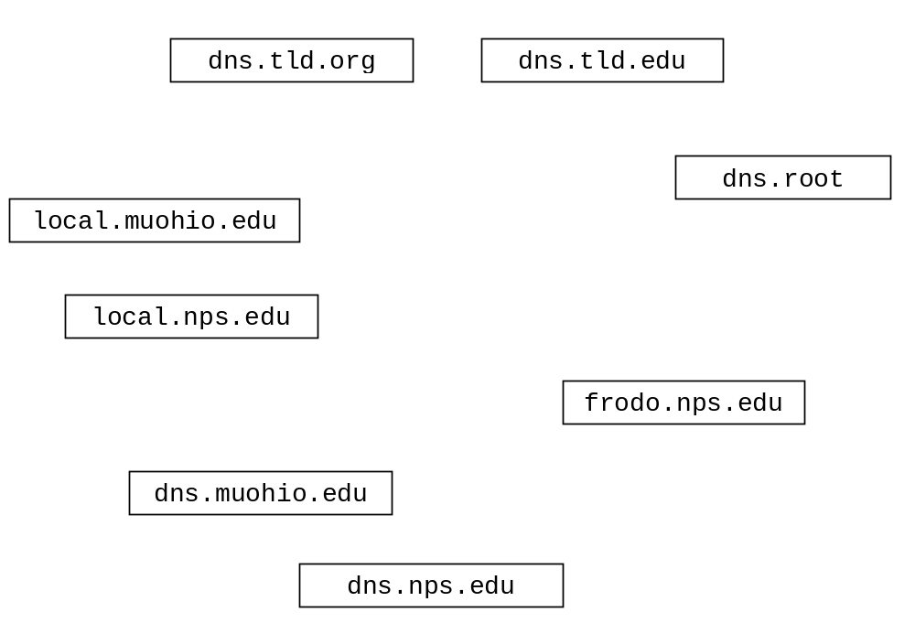

- Each of the following terms pertains to a difficulty that may be encountered in a wireless network. Match each term with the appropriate description by writing the letter for the term next to the description. (8 points)

- Hidden Terminal Problem
- Multipath Propagation
- Signal Attenuation
- Signal Interference

_________ Loss of RF signal strength as the signal travels over a distance and/or passes through obstacles such as walls.

_________ The inability of one wireless node to hear another wireless node due to the presence of an RF energy obstruction between the nodes.

_________ Degradation RF signal quality due to the presence of device such as wireless phone which are transmitting RF signals.

_________ Multiple arrivals of a given signal at the receiver because the same signal has followed several paths to reach the receiver.

- Which distributed application architecture paradigm did project five, “Chat,” fall into? Circle one. (4 points)

Client-server Peer-to-peer Hybrid peer to peer

- Which distributed application architecture paradigm did project three, “Multi-User SpaceGame,” fall into? Circle one. (4 points)

Client-server Peer-to-peer Hybrid peer to peer

- Complete the Server class on the next page. Do not worry about handling exceptions. Allow the main method to throw them to the OS. (50 points)

- The Serves handles clients sequentially (no multi-threading).
- Clients send an unknown number of floats (4 bytes each) to the server in a single datagram using UDP. The maximum number of floats that can be sent in a single datagram is 100.
- The Server determines the number of floats in the datagram and calculates the sum of them. It sends the sum back to the client as a double using UDP.
- After serving one client, the server again waits for a datagram from another client.
- After serving ten clients, the server closes down.
- The Server listens on port number 7777.
- Close all open streams and sockets before the program exits.

import java.io.*;
import java.net.*;

public class UDPSumServer {

public static void main(String[] args) throws Exception
{

